CS 255 Business Requirements Document Template

Complete this template by replacing the bracketed text with the relevant information.

This template lays out all the different sections that you need to complete for Project One. Each section has guiding questions to prompt your thinking. These questions are meant to guide your initial responses to each area. You are encouraged to go beyond these questions using what you have learned in your readings. You will need to continually reference the interview transcript as you work to make sure that you are addressing your client’s needs. There is no required length for the final document. Instead, the goal is to complete each section based on your client’s needs.

Tip: You should respond in a bulleted list for each section. This will make your thoughts easier to reference when you move into the design phase for Project Two. One starter bullet has been provided for you in each section, but you will need to add more.

System Components and Design

Purpose
What is the purpose of this project? Who is the client and what do they want their system to be able to do?
- The system's objective is to meet the client's requirements for a solution that efficiently and user-friendlily advances their business operations and boosts overall productivity. The system seeks to optimize processes, furnish essential functionalities, and back various users in their corresponding roles.

System Background
What does DriverPass want the system to do? What is the problem they want to fix? What are the different components needed for this system?
- The system shall be structured to tackle the precise requisites and hurdles encountered by the client's organization. It shall incorporate diverse components and technologies to forge an all-encompassing solution that harmonizes with the client's business goals and elevates their competitive edge in the market.

Objectives and Goals
What should this system be able to do when it is completed? What measurable tasks need to be included in the system design to achieve this?
- The main aims and targets of the system encompass the following:
- Automate manual tasks and optimize business processes to heighten efficiency.
- Enhance data accuracy and accessibility to bolster improved decision-making.
- Elevate collaboration and communication among diverse users and departments.
- Deliver a user-friendly interface demanding minimal training and support.
- Assure the system's scalability and adaptability to accommodate forthcoming growth and organizational changes.

Requirements

Nonfunctional Requirements
In this section, you will detail the different nonfunctional requirements for the DriverPass system. You will need to think about the different things that the system needs to function properly.

Performance Requirements
What environments (web-based, application, etc.) does this system need to run in? How fast should the system run? How often should the system be updated?
- The system must furnish rapid response times to guarantee a seamless user experience.
- It must accommodate concurrent users without notable performance deterioration.
- Response times for critical functions must stay within predefined thresholds.

Platform Constraints
What platforms (Windows, Unix, etc.) should the system run on? Does the back end require any tools, such as a database, to support this application?
- The system must align with the client's current technology infrastructure.
- It must also cater to multiple platforms, encompassing desktop and mobile devices.

Accuracy and Precision
How will you distinguish between different users? Is the input case-sensitive? When should the system inform the admin of a problem?
- The system must uphold a high standard of data accuracy and precision.
- Its calculation and reporting functionalities must generate precise and reliable results.

Adaptability
Can you make changes to the user (add/remove/modify) without changing code? How will the system adapt to platform updates? What type of access does the IT admin need?
- The system must possess flexibility and effortless customizability to adapt to forthcoming business needs and process alterations.
- It should facilitate smooth integration with other systems or third-party applications.

Security
What is required for the user to log in? How can you secure the connection or the data exchange between the client and the server? What should happen to the account if there is a “brute force” hacking attempt? What happens if the user forgets their password?
- The system must enact robust security measures to safeguard sensitive data against unauthorized access, alteration, or disclosure.
- It should establish user authentication and authorization mechanisms to enforce proper access controls.
- Data transmission and storage should undergo encryption to uphold confidentiality.

Functional Requirements
Using the information from the scenario, think about the different functions the system needs to provide. Each of your bullets should start with “The system shall . . .” For example, one functional requirement might be, “The system shall validate user credentials when logging in.”
- The system will verify user credentials during the login process.
- The system will furnish a driver application form for gathering driver information.
- The system will validate driver documents, encompassing driver's licenses and insurance documents.
- The system will oversee driver profiles, including personal details and document storage.
- The system will offer an analytics dashboard that exhibits driver acquisition and retention metrics.

User Interface
What are the needs of the interface? Who are the different users for this interface? What will each user need to be able to do through the interface? How will the user interact with the interface (mobile, browser, etc.)?

- The interface must possess a user-friendly design that facilitates easy navigation.
- The interface will serve various user roles, including drivers, admins, and analytics users.
- Drivers should be capable of submitting applications and handling their profiles via the interface.
- Admins should have the capability to administer driver profiles, review driver documents, and access analytics through the interface.
- Analytics users should be able to access and review analytics data via the interface.
- The interface should adopt a web-based approach and remain accessible through any contemporary web browser.

Assumptions
What things were not specifically addressed in your design above? What assumptions are you making in your design about the users or the technology they have?
- Users possess a fundamental proficiency in using a computer and navigating a web-based interface.
- The IT administrator possesses adequate knowledge and skills for system management and maintenance.
- Users have access to a dependable internet connection.

Limitations
Any system you build will naturally have limitations. What limitations do you see in your system design? What limitations do you have as far as resources, time, budget, or technology?
- There is a constrained budget available for both the development and ongoing maintenance of the system.
- The project must adhere to a tight timeline for completion.
- Initially, the system will only support the English language.

Gantt Chart
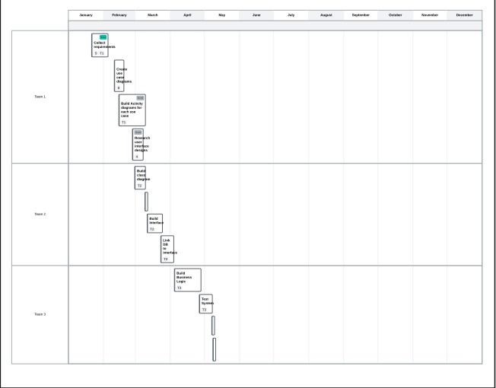
Please include a screenshot of the GANTT chart that you created with Lucidchart. Be sure to check that it meets the plan described by the characters in the interview.

